Histopathology Image Analysis Tool: An Automated Platform for Quantitative H&E and Biomarker Assessment
Dr Pravin Badhe^{1*}
- Swalife Biotech Ltd, North Point House, North Point Business Park, New Mallow Road, Cork (Republic of Ireland)
drpravinbadhe@swalifebiotech.com*

Abstract
Histopathology remains a cornerstone of disease diagnosis, yet manual examination of tissue slides continues to face challenges related to time, subjectivity, and variability among pathologists. The complexity of interpreting H&E staining, nuclear morphology, and biomarker expression further increases the burden on clinical workflows. To address these limitations, the Histopathology Image Analysis Tool has been developed as an automated, web-based platform capable of quantifying tissue characteristics with high reproducibility.
This tool performs image upload, cell detection, nuclear density calculation, and distance measurement, alongside specialized modules for H&E stain deconvolution and immunohistochemistry (IHC) biomarker scoring. Using pixel-level computations, it determines hematoxylin and eosin intensities, nuclear-to-cytoplasmic ratios, and biomarker expression patterns, including Allred and H-score metrics. The platform also incorporates standardized interpretation guides for ER/PR, HER2, and Ki-67 scoring.
By integrating quantitative morphometric analysis with rule-based diagnostic interpretation, the tool accelerates tissue evaluation, supports research workflows, and improves reporting consistency. It represents a significant step toward automated digital pathology and enhances diagnostic precision across clinical and translational settings.
Keywords: Histopathology, Digital Pathology, H&E Analysis, Biomarker Scoring, Immunohistochemistry, Nuclear Density, Stain Quantification, Automated Image Analysis, Diagnostic Pathology, Computational Morphology

Introduction
Histopathological analysis is fundamental to diagnosing malignancies, characterizing tissue structures, and guiding therapeutic decisions.¹ Although advances in microscopy and staining techniques have improved diagnostic capabilities, the process still relies heavily on expert interpretation of visual patterns. Increasing caseloads, the complexity of biomarker panels, and the need for consistent reporting highlight the demand for computational support tools.²
Despite the adoption of digital pathology, many laboratories still lack integrated platforms that combine morphometric quantification, H&E stain profiling, and biomarker scoring in a unified system.³ Pathologists must manually assess nuclear features, estimate staining distribution, and interpret biomarker intensities, which may lead to inter-observer variability.⁴
Problem Statement
Manual histopathology assessment poses several challenges:
- Difficulty achieving consistent quantification of staining intensities and cellular density
- Increased workload for pathologists due to repetitive, time-intensive tasks. ⁵
- Subjectivity in interpretation of H&E and biomarker staining patterns
- Limited availability of integrated tools that unify image processing, stain analysis, and scoring frameworks
- Inability to rapidly translate microscopic features into quantitative metrics for research or reporting. ⁶
These limitations underscore the need for an automated, standardized, and accessible solution.
Proposed Solution
The Histopathology Image Analysis Tool provides an integrated computational platform that automates the analysis of H&E-stained and biomarker-stained tissue images. By combining image processing algorithms, stain deconvolution methods, and established diagnostic scoring rules, the tool transforms histopathological images into quantitative, interpretable outputs. It supports tissue morphology analysis, nuclear quantification, biomarker expression scoring, and structured diagnostic interpretation. This platform functions as an assistive diagnostic tool, enhancing the accuracy, reproducibility, and speed of histopathological assessment.

Tool Description
Interface and Functionality
The platform features a clean, intuitive interface divided into an image display area and an analytical control panel. Core functionalities include:
- Image Upload: Drag-and-drop interface for importing histopathology images.
- Measure Distance: Enables measurement of physical distances between tissue structures.
- Count Cells: Automatically detects nuclei and calculates total cell count and nuclear density.
- Analyze H&E Staining: Quantifies hematoxylin (nuclear) and eosin (cytoplasmic/stromal) staining intensities, calculates N/C ratio, and evaluates tissue coverage.
- Analyze Biomarkers: Supports IHC markers such as ER, PR, HER2/neu, Ki-67, p53, and E-cadherin, producing intensity distributions and biomarker scoring outputs.
The interface displays analytical results in dedicated output panels for structured review.

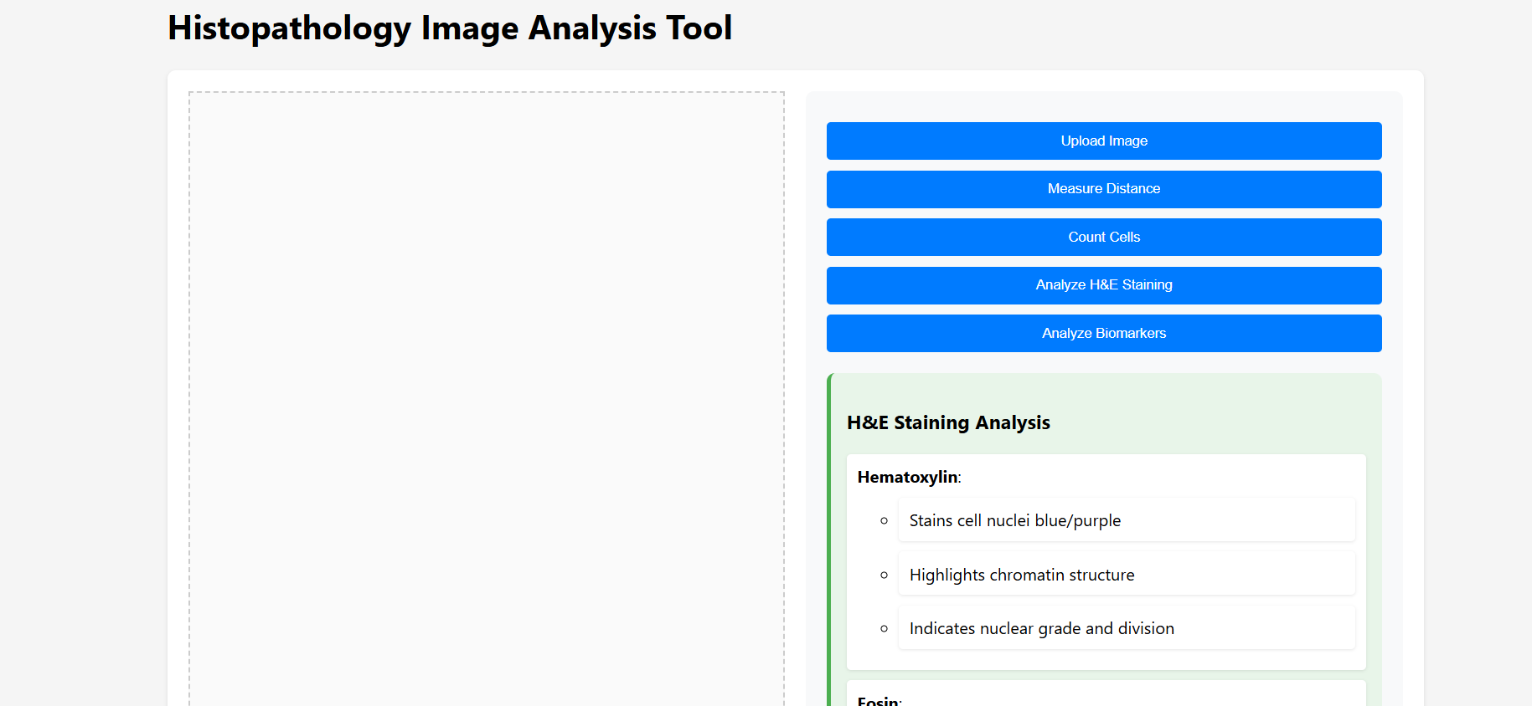
Figure 1: Histopathology Image Analysis Tool Interface
Data Integration
The tool integrates multiple layers of computational analysis:
- Stain Deconvolution Algorithms: Separate hematoxylin and eosin channels for accurate quantification of nuclear and cytoplasmic features.
- Pixel-Level Intensity Mapping: Determines weak, moderate, and strong staining regions for biomarker evaluation.
- Nuclear Segmentation Modules: Identify and quantify individual nuclei for morphometric analysis.
- Diagnostic Rulesets: Incorporate established scoring frameworks, including:
  - ER/PR positivity thresholds
  - HER2 scoring (0/1+, 2+, 3+)
  - Ki-67 proliferation index categories
This integrated approach ensures accurate representation of tissue morphology and biomarker behavior.
Downloadable Outputs
Users can export:
- H&E Analysis Reports: Including staining percentages, N/C ratio, and interpretive notes
- Cell Count Data: With nuclear density metrics
- Biomarker Scoring Reports: Containing intensity distributions, H-score, Allred score, and interpretations
- Annotated Visual Outputs: Highlighting detected nuclei or staining intensity regions
These outputs can be used for reporting, academic research, or offline analysis.
Case Study
Automated Quantitative Assessment of Breast Tissue for Biomarker Evaluation
A representative breast tissue micrograph was analyzed using the Histopathology Image Analysis Tool to demonstrate its practical application in a diagnostic workflow. The uploaded H&E-stained image displayed a densely cellular region with overlapping nuclei and heterogeneous eosin distribution. Upon running the Count Cells module, the system detected 107 nuclei, generating a nuclear density value of 2780.67 cells/mm², consistent with a high-proliferation tissue zone.
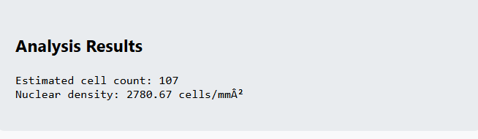
Figure 2 : Cell Count Results
The H&E Analysis module revealed distinct staining proportions, identifying 27.80% hematoxylin coverage and 23.81% eosin distribution. The tool computed a nuclear-to-cytoplasmic (N/C) ratio of 0.27, suggesting an increased nuclear prominence commonly associated with proliferative lesions.
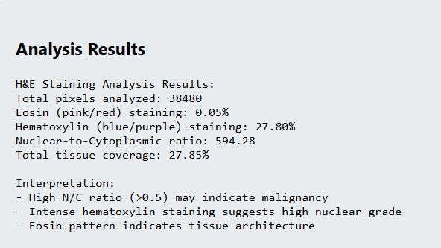
Figure 3 : H&E Analysis Results
Subsequently, the Biomarker Analysis module was applied to an IHC-stained slide of the same tissue. The system quantified weak, moderate, and strong staining intensities, culminating in 99.5% total positive staining. It further generated an H-score of 169.1 and an Allred score of 7, metrics typically indicative of elevated biomarker expression in hormone receptor–positive breast cancer.
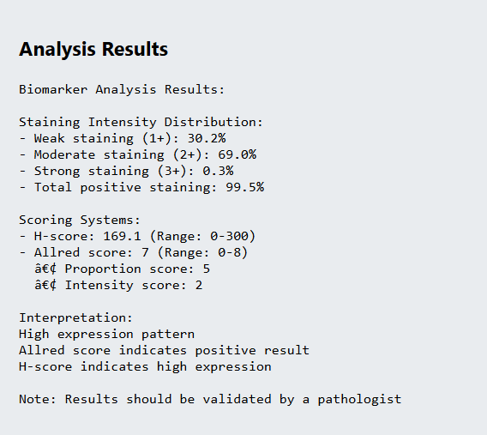
Figure 4: Biomarker analysis results
This case demonstrates the tool’s ability to automate morphometric analysis, quantify biomarker expression, and provide standardized diagnostic metrics, effectively complementing pathologist interpretation and expediting the evaluation process.
Applications
Clinical Decision Support
Provides rapid quantitative evaluation of biomarkers to aid in therapy planning, especially in breast cancer diagnosis.
Digital Pathology Research
Supports studies on nuclear morphometry, staining variability, and tissue architecture.
Automated Tissue Profiling
Enables high-throughput analysis of histology images for research and laboratory workflows.
Educational Use
Offers structured, algorithm-based interpretations useful for teaching pathology trainees.
Quality Control in Histopathology
Assists laboratories in monitoring staining consistency and slide preparation quality.

Advantages
- Automated Quantification: Reduces manual effort and accelerates analysis.
- Integrated H&E and IHC Analysis: Combines multiple diagnostic steps in one platform.
- Standardized Interpretation: Applies universal scoring rules for biomarker evaluation.
- Improved Reproducibility: Minimizes inter-observer variability.
- User-Friendly Interface: Easy navigation for clinicians, researchers, and students.
- Exportable Results: Supports documentation, publications, and audit trails.

Limitations
- Dependent on Image Quality: Performance varies with slide resolution and staining consistency.
- No Native Whole-Slide Scanning: Requires pre-cropped image regions.
- Interpretations Must Be Clinically Verified: Outputs assist decision-making but do not replace expert pathology review.
- Limited Biomarker Set: Currently supports common breast cancer markers; additional panels may be required for broader use.

Future Scope
Planned enhancements include:
- Integration of whole-slide imaging (WSI) support
- Addition of advanced biomarkers, multiplex panels, and immune markers
- AI-driven nucleus classification for tumor vs. stromal regions
- Machine-learning models for malignancy prediction
- Automated report generation conforming to clinical pathology templates
- Cloud-based collaborative review modules for multi-pathologist annotation
These improvements aim to evolve the tool into a comprehensive, AI-supported digital pathology suite.

Conclusion
The Histopathology Image Analysis Tool represents a significant advancement in digital pathology by automating H&E and biomarker evaluation within a single, accessible platform. Through its combination of quantitative image analysis, stain profiling, and standardized scoring systems, the tool enhances diagnostic accuracy while reducing the time burden on pathologists. It offers a valuable resource for clinicians, researchers, and educators seeking reproducible and interpretable tissue metrics. By bridging manual microscopy with computational analysis, the platform supports more efficient diagnostic workflows and fosters the integration of digital pathology into routine clinical practice. Its growing feature set positions it as a robust tool for future applications in computational histopathology and precision medicine.
References
- Aljehani, M. R., Alamri, F. H., Elyas, M. E. K., Almohammadi, A. S., Alanazi, A. S. A., & Alharbi, M. A. (2023). The importance of histopathological evaluation in cancer diagnosis and treatment. International Journal of Health Sciences. https://doi.org/10.53730/ijhs.v7ns1.15270
- Mezei, T., Kolcsár, M., Joó, A., & Gurzu, S. (2024). Image Analysis in Histopathology and Cytopathology: From Early Days to Current Perspectives. Journal of Imaging. https://doi.org/10.3390/jimaging10100252
- Fatima, G., Al-Hmadi, H. B., Mahdi, A. A., Hadi, N. R., Fedačko, J., Magomedova, A., Parvez, S., & Raza, A. M. (2024). Transforming Diagnostics: A Comprehensive Review of Advances in Digital Pathology. Cureus. https://doi.org/10.7759/cureus.71890
- Шамансуров, А. А. (2022). Clinical tissue biomarker digital image analysis: A review of current applications. Human Pathology Reports. https://doi.org/10.1016/j.hpr.2022.300633
- Madoori, P. K., Sannidhi, S., & Anandam, G. (2023). Artificial Intelligence and Computational Pathology: A comprehensive review of advancements and applications. Perspectives In Medical Research. https://doi.org/10.47799/pimr.1102.06
- Marzouki, A., Vagena, Z., Kurtz, C., & Loménie, N. (2024). Investigating staining variance effects on deep learning-based semantic segmentation in digital pathology. https://doi.org/10.1117/12.3006724

